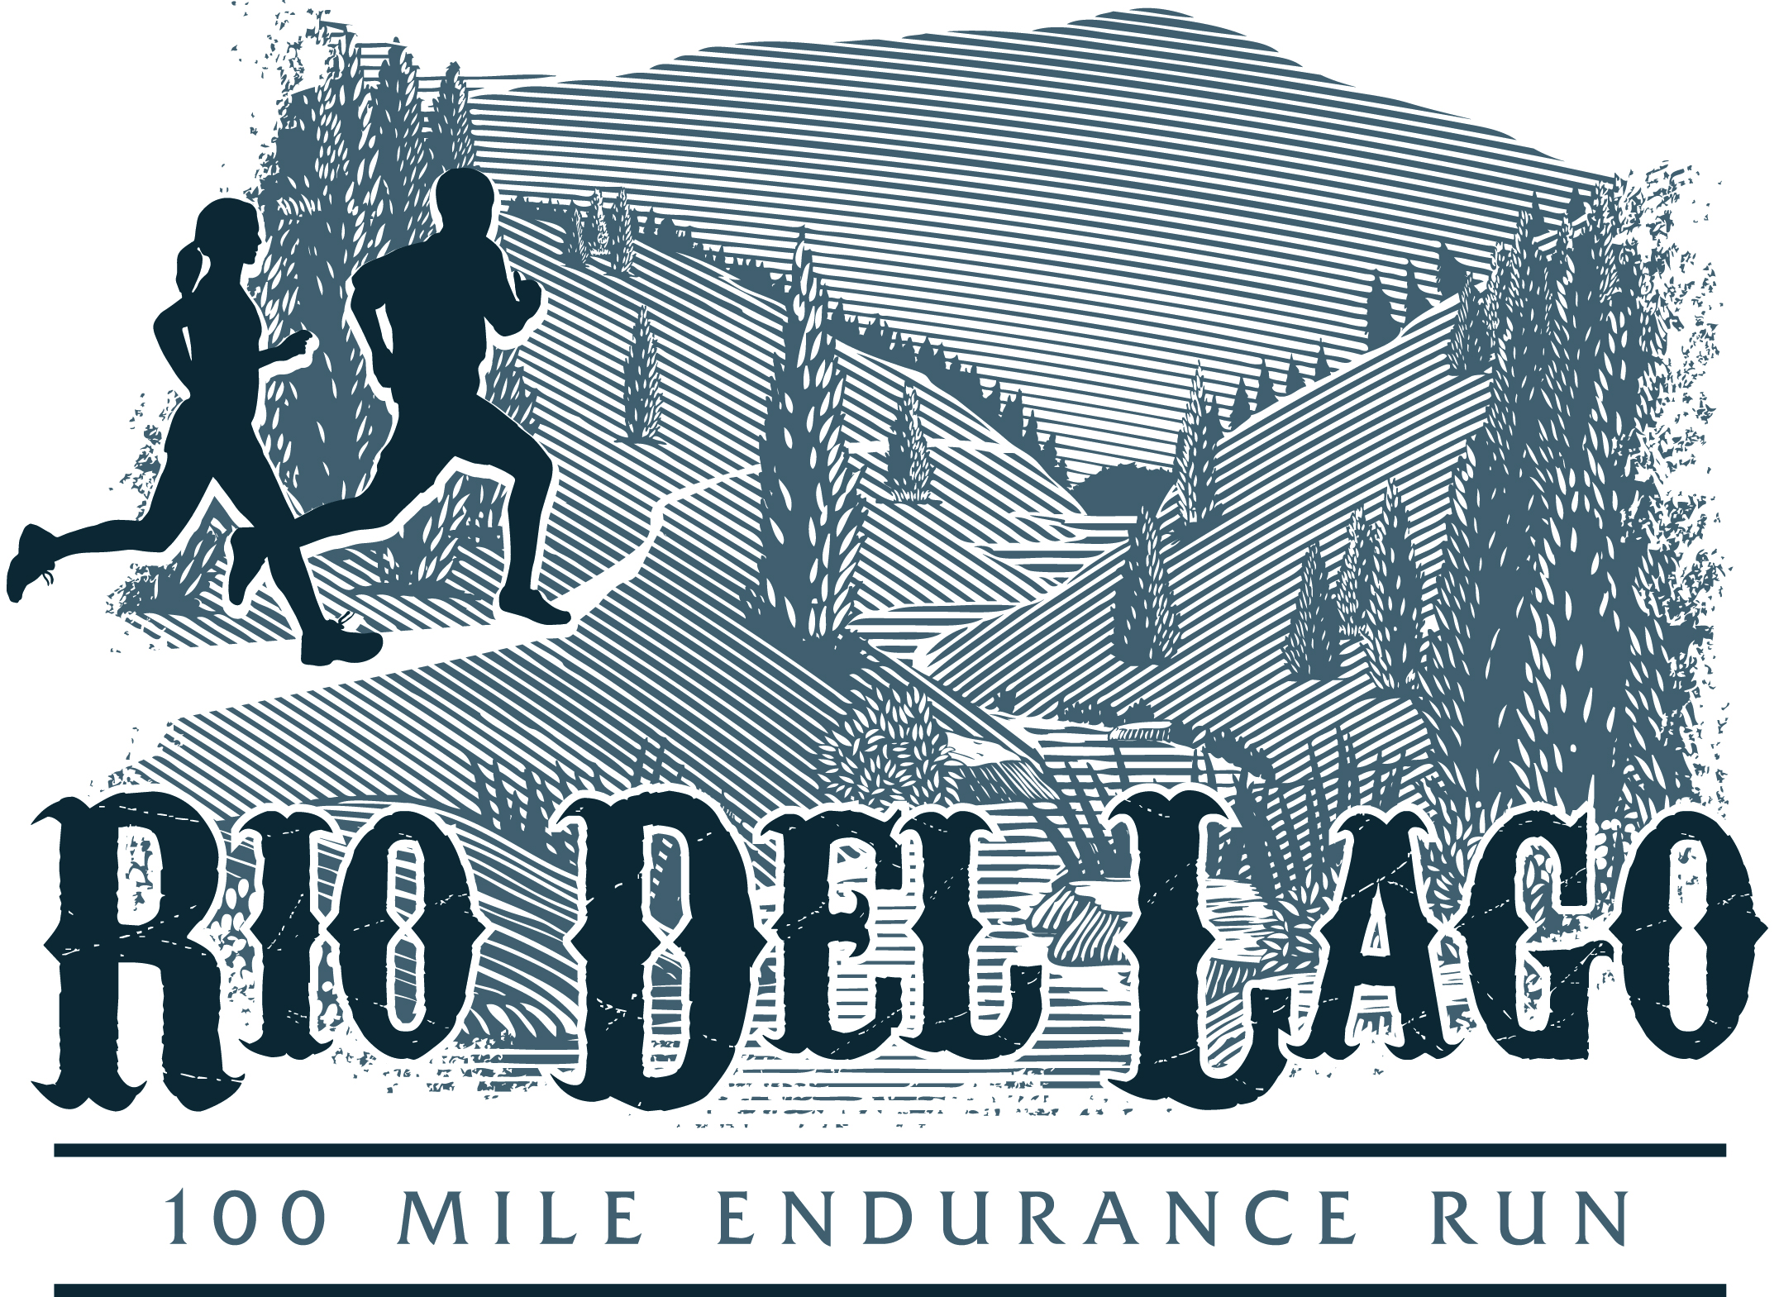
Rio Del Lago 100
Volunteer Service Form

Each Rio Del Lago 100 runner is required to volunteer a minimum of 6 hours of service towards trail maintenance, a race event, or other community service between January 1, 2013 and October 15, 2013 as a condition for participation at the 2013 event.

Participant Name: ______________________________________________

Mailing Address: _______________________________________________

City: ____________________________ State: ________ Zip: ___________

Service Hours performed (Minimum of 6 hours required): ______________

Date & Location of Service: _______________________________________

Type of service (trail work, event volunteer, other): ___________________

Certification by Event/Race Director, Park Official, Coordinator

Name and Title: ________________________________________________

Phone Number: ________________________________________________

Email: ________________________________________________________

Signature: _________________________________ Date: ______________

Completed forms should be mailed to: Pamela Madigan 842 43rd Ave San Francisco, CA 94121. Forms must be received by October 30, 2013. For additional information contact: info@rio100mile.com

(Email us a photo of you volunteering for our website & we will knock your requirement down to 5.5 hours!)

